**“Shree Ganeshay Namah”**

**Questions:-**

1. **Table A(1 1 2 0 2 NULL) and B(NULL NULL 1 1 1 2). What is output of inner, left, right and full outer join?**
2. **Table A(1,1,1,1) and B(1,1,1). What is output of inner, left, right and full outer join?**
3. **Scenario of UNION, UNION ALL, INTERSECT, MINUS and Joins?**
4. **Parent-Child Relationship or Primary-Foreign key relationship?**
5. **How to find duplicate records/rows in a table?**
6. **How to delete duplicate records/rows in a table?**
7. **How to find second highest salary in a table?**
8. **How to find 10th highest salary of employee**
9. **How to find second highest salary in a table based on dept_no?**
10. **How to find EMPNO which is working on multiple department?**
11. **Scenario:- How to convert single row into multiple rows?**
12. **Scenario:- How to convert single row into multiple rows?**
13. **Scenario:- How to convert multiple row into single row?**
14. **Scenario:- Print previous row data?**
15. **Scenario:- Sum of previous row data?**
16. Scenario:- Differentiate numbers and alphabets?
17. **How to fetch monthly salary of Employee if annual salary is given?**
18. **What is the Query to fetch first record from Employee table?**
19. **What is the Query to fetch last record from the table?**
20. **What is Query to display last 5 Records from Employee table?**
21. **What is Query to display Nth Record from Employee table?**
22. **How to get 3 Highest salaries records from Employee table?**
23. **How to Display Odd rows in Employee table?**
24. **How to Display Even rows in Employee table?**
25. **How to fetch 3rd highest salary using Rank Function?**
26. **How can i create table with same structure of Employee table?**
27. **How can i create table with same structure with data of Employee table?**
28. **Display first 50% records from Employee table?**
29. **Display last 50% records from Employee table?**
30. **How do i fetch only common records between 2 tables?**
31. **Find Query to get information of Employee where Employee is not assigned to the department**
32. **How to get distinct records from the table without using distinct keyword.**
33. **How to write sql query for the below scenario**
34. **How to fetch all the records from Employee who’s joining year is 2017?**
35. **What is SQL Query to find maximum salary of each department?**
36. **How Do you find all Employees with its managers?(Consider there is manager id also in Employee table)**
37. **How to display following using query?**
38. **How to add the email validation using only one query?**
39. **How to display 1 to 100 Numbers with query?**
40. **How to remove duplicate rows from table?**
41. **How to find count of duplicate rows?**
42. **How to find max salary of table?**
43. **How to find max salary of table and print employee details of that salary as well?**
44. **How to find all employee details along with new field of max salary of table?**
45. **How to find max salary of each department?**
46. **How to find max salary of each department and print employee details of that salary as well?**
47. **How to find all employee details along with new field of max salary of each department?**
48. **How to get number of employees, max salary and min salary of employee of each department?**
49. **What is avg salary of group 10?**
50. **If I have 100 rows in A table and 10million rows in B table. How much time it will take to execute query? Also if I have index on table A?**
51. **Find the list of employees who are not managers?**
52. **Find dept wise MAX salary of employee?**
53. **Find dept wise MAX salary of employee in year 2018?**
54. **How to find employees whose salary is greater than or equal to the average salary for their departments?**
55. **How to find primary key and foreign key of any table?**
56. **Table A(1,2,3,4,5) and B(1,2,3). How to find records exist in A but not in B and vise-versa?**
57. **How to find employee details whose start_dtm is max?**
58. **How to extract those dept numbers which has more than 5 employees in it?**
59. **What is the output-select * from bill_itm where NULL=NULL;?**
60. **Scenario to find average salary?**
61. **Scenario:- Find top 2 salary of Male and Female from employee table?**

**Answers:-**

1. **Table A(1 1 2 0 2 NULL) and B(NULL NULL 1 1 1 2). What is output of inner, left, right and full outer join?**INNER JOIN:- 8 (1,1,1,1,1,1,2,2)

LEFT OUTER JOIN:- 10 (1,1,1,1,1,1,2,2,0,NULL)

RIGHT OUTER JOIN:- 10 (1,1,1,1,1,1,2,2,NULL,NULL)

FULL OUTER JOIN:- 12 (1,1,1,1,1,1,2,2,0,NULL,NULL,NULL)

1. **Table A(1,1,1,1) and B(1,1,1). What is output of inner, left, right and full outer join?**WITH temp_1 AS

(

SELECT 1 A_1 FROM DUAL

UNION ALL

SELECT 1 FROM DUAL

UNION ALL

SELECT 1 FROM DUAL

UNION ALL

SELECT 1 FROM DUAL

),

temp_2 AS

(

SELECT 1 A_2 FROM DUAL

UNION ALL

SELECT 1 FROM DUAL

UNION ALL

SELECT 1 FROM DUAL

)

SELECT * FROM TEMP_1 INNER JOIN TEMP_2 ON TEMP_1.A_1 = TEMP_2.A_2;

INNER JOIN:- 12 (1,1,1, 1,1,1, 1,1,1, 1,1,1)

LEFT OUTER JOIN:- 12 (1,1,1, 1,1,1, 1,1,1, 1,1,1)

RIGHT OUTER JOIN:- 12 (1,1,1, 1,1,1, 1,1,1, 1,1,1)

FULL OUTER JOIN:- 12 (1,1,1, 1,1,1, 1,1,1, 1,1,1)

1. **Scenario of UNION, UNION ALL, INTERSECT, MINUS and Joins?**DROP TABLE A;

CREATE TABLE A(ID NUMBER(20));

INSERT INTO A VALUES(1);

INSERT INTO A VALUES(1);

INSERT INTO A VALUES(1);

INSERT INTO A VALUES(2);

INSERT INTO A VALUES(2);

INSERT INTO A VALUES(3);

INSERT INTO A VALUES(4);

INSERT INTO A VALUES('');

INSERT INTO A VALUES('');

COMMIT;

DROP TABLE B;

CREATE TABLE B(ID NUMBER(20));

INSERT INTO B VALUES(1);

INSERT INTO B VALUES(1);

INSERT INTO B VALUES(2);

INSERT INTO B VALUES(3);

INSERT INTO B VALUES('');

COMMIT;

SELECT * FROM A;

--1,1,1,2,2,3,4,NULL,NULL

SELECT * FROM B;

--1,1,2,3,NULL

SELECT ID FROM A

UNION

SELECT ID FROM B;

--1,2,3,4,NULL

SELECT ID FROM A

UNION ALL

SELECT ID FROM B;

--1,1,1,2,2,3,4,NULL,NULL,1,1,2,3,NULL

SELECT ID FROM A

INTERSECT

SELECT ID FROM B;

--1 2 3 NULL

SELECT ID FROM A

MINUS

SELECT ID FROM B;

--4

SELECT A.ID FROM A INNER JOIN B

ON A.ID=B.ID;

--1,1,1,1,1,1,2,2,3

SELECT A.ID FROM A LEFT OUTER JOIN B

ON A.ID=B.ID;

--1,1,1,1,1,1,2,2,3,NULL,NULL,4

SELECT A.ID FROM A RIGHT OUTER JOIN B

ON A.ID=B.ID;

--1,1,1,1,1,1,2,2,3,NULL

SELECT A.ID FROM A FULL OUTER JOIN B

ON A.ID=B.ID;

--1,1,1,1,1,1,2,2,3,4,NULL,NULL,NULL

SELECT A.ID FROM A,B

WHERE A.ID=B.ID;

--1,1,1,1,1,1,2,2,3

1. **Parent-Child Relationship or Primary-Foreign key relationship?**

**Parent Table:-**

Create table dept(dept_no int PRIMARY KEY, dept_nm varchar(20) not null);

**Child Table:-**

Create table emp(e_id int PRIMARY KEY, e_nm varchar(20) not null, dept_no int, CONSTRAINT dept_fk FOREIGN KEY(dept_no) REFERENCES dept(dept_no) );

Rules:-

Creation of Table:- First create Parent table than child table.

Insertion of rows:- First insert rows in parent table than insert in child table.

Ex:- Insert into emp values(4,'Mohit',104);

--integrity constraint (SYSTEM.DEPT_FK) violated - parent key not found

Note:- Because dept_no 104 is not present in parent table(dept).

Deletion of table:- First delete child table than delete parent table.

Ex:- Delete from dept where dept_no=101;

--integrity constraint (SYSTEM.DEPT_FK) violated - child record found

Note:- Because reference of dept_no 101 is present on child table(emp).

1. **How to find duplicate records/rows in a table?**

DROP TABLE "EMPLOYEE";

CREATE TABLE "EMPLOYEE"

( "EMP_NO" NUMBER(*,0),

"EMP_NM" VARCHAR2(20 BYTE),

"SALARY" NUMBER

);

TRUNCATE TABLE EMPLOYEE;

INSERT INTO EMPLOYEE (EMP_NO,EMP_NM,SALARY) VALUES (101,'MOHIT',5000);

INSERT INTO EMPLOYEE (EMP_NO,EMP_NM,SALARY) VALUES (101,'MOHIT',5000);

INSERT INTO EMPLOYEE (EMP_NO,EMP_NM,SALARY) VALUES (101,'MOHIT',5000);

INSERT INTO EMPLOYEE (EMP_NO,EMP_NM,SALARY) VALUES (102,'RAM',3000);

INSERT INTO EMPLOYEE (EMP_NO,EMP_NM,SALARY) VALUES (102,'RAM',3000);

INSERT INTO EMPLOYEE (EMP_NO,EMP_NM,SALARY) VALUES (103,'ROBERT',7000);

INSERT INTO EMPLOYEE (EMP_NO,EMP_NM,SALARY) VALUES (104,'MARY',3600);

INSERT INTO EMPLOYEE (EMP_NO,EMP_NM,SALARY) VALUES (104,'MARY',7000);

COMMIT;

SELECT ROWID,EMP_NO,EMP_NM,SALARY FROM EMPLOYEE;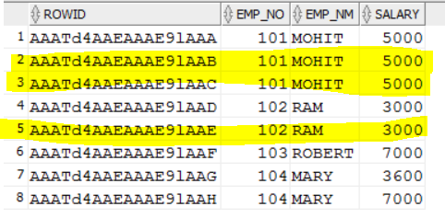

**Query:-**

--1st WAY

SELECT * FROM EMPLOYEE WHERE ROWID NOT IN

(SELECT MAX(ROWID) FROM EMPLOYEE GROUP BY EMP_NO,EMP_NM,SALARY);

--2nd WAY

SELECT * FROM EMPLOYEE A WHERE ROWID NOT IN

(SELECT MAX(ROWID) FROM EMPLOYEE B WHERE A.EMP_NO = B.EMP_NO AND A.EMP_NM=B.EMP_NM AND A.SALARY=B.SALARY);

--3rd WAY

SELECT * FROM EMPLOYEE A WHERE ROWID<

(SELECT MAX(ROWID) FROM EMPLOYEE B WHERE A.EMP_NO=B.EMP_NO AND A.EMP_NM=B.EMP_NM AND A.SALARY=B.SALARY);

--4th WAY

SELECT * FROM EMPLOYEE A WHERE ROWID>

(SELECT MIN(ROWID) FROM EMPLOYEE B WHERE A.EMP_NO=B.EMP_NO AND A.EMP_NM=B.EMP_NM AND A.SALARY=B.SALARY);

--5th WAY

SELECT * FROM EMPLOYEE A WHERE EXISTS

(SELECT 1 FROM EMPLOYEE B WHERE A.EMP_NO=B.EMP_NO AND A.EMP_NM=B.EMP_NM AND A.SALARY=B.SALARY AND A.ROWID>B.ROWID);

--6th WAY USING ROW_NUMBER()

SELECT * FROM EMPLOYEE WHERE ROWID IN

(SELECT RID FROM

(SELECT ROWID RID, ROW_NUMBER() OVER(PARTITION BY EMP_NO,EMP_NM,SALARY

ORDER BY EMP_NO)RN FROM EMPLOYEE

)WHERE RN > 1

);

--7th WAY USING DENSE_RANK()

SELECT * FROM EMPLOYEE WHERE ROWID IN

(SELECT RID FROM (SELECT ROWID RID, DENSE_RANK() OVER (PARTITION BY EMP_NO,EMP_NM,SALARY

ORDER BY ROWID) RN FROM EMPLOYEE

)WHERE RN > 1

);

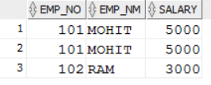

1. **How to delete duplicate records/rows in a table?**

--1st WAY

DELETE FROM EMPLOYEE WHERE ROWID NOT IN

(SELECT MAX(ROWID) FROM EMPLOYEE GROUP BY EMP_NO,EMP_NM,SALARY);

--2nd WAY

DELETE FROM EMPLOYEE A WHERE ROWID NOT IN

(SELECT MAX(ROWID) FROM EMPLOYEE B WHERE A.EMP_NO = B.EMP_NO AND A.EMP_NM=B.EMP_NM AND A.SALARY=B.SALARY);

--3rd WAY

DELETE FROM EMPLOYEE A WHERE ROWID<

(SELECT MAX(ROWID) FROM EMPLOYEE B WHERE A.EMP_NO=B.EMP_NO AND A.EMP_NM=B.EMP_NM AND A.SALARY=B.SALARY);

--4th WAY

DELETE FROM EMPLOYEE A WHERE ROWID>

(SELECT MIN(ROWID) FROM EMPLOYEE B WHERE A.EMP_NO=B.EMP_NO AND A.EMP_NM=B.EMP_NM AND A.SALARY=B.SALARY);

--5th WAY

DELETE FROM EMPLOYEE A WHERE EXISTS

(SELECT 1 FROM EMPLOYEE B WHERE A.EMP_NO=B.EMP_NO AND A.EMP_NM=B.EMP_NM AND A.SALARY=B.SALARY AND A.ROWID>B.ROWID);

--6th WAY USING ROW_NUMBER()

DELETE FROM EMPLOYEE WHERE ROWID IN

(SELECT RID FROM(SELECT ROWID RID, ROW_NUMBER() OVER(PARTITION BY EMP_NO,EMP_NM,SALARY ORDER BY EMP_NO)RN FROM EMPLOYEE

)WHERE RN > 1

);

--7th WAY USING DENSE_RANK()

DELETE FROM EMPLOYEE WHERE ROWID IN

(SELECT RID FROM(SELECT ROWID RID, DENSE_RANK() OVER(PARTITION BY EMP_NO,EMP_NM,SALARY ORDER BY ROWID) RN FROM EMPLOYEE

)WHERE RN > 1

);



1. **How to find second highest salary in a table?**DROP TABLE "EMPLOYEE";

CREATE TABLE "EMPLOYEE"

( "EMP_NO" NUMBER(*,0),

"EMP_NM" VARCHAR2(20 BYTE),

"SALARY" NUMBER

);

TRUNCATE TABLE EMPLOYEE;

INSERT INTO EMPLOYEE (EMP_NO,EMP_NM,SALARY) VALUES (101,'MOHIT',5000);

INSERT INTO EMPLOYEE (EMP_NO,EMP_NM,SALARY) VALUES (101,'MOHIT',5000);

INSERT INTO EMPLOYEE (EMP_NO,EMP_NM,SALARY) VALUES (101,'MOHIT',5000);

INSERT INTO EMPLOYEE (EMP_NO,EMP_NM,SALARY) VALUES (102,'RAM',3000);

INSERT INTO EMPLOYEE (EMP_NO,EMP_NM,SALARY) VALUES (102,'RAM',3000);

INSERT INTO EMPLOYEE (EMP_NO,EMP_NM,SALARY) VALUES (103,'ROBERT',7000);

INSERT INTO EMPLOYEE (EMP_NO,EMP_NM,SALARY) VALUES (104,'MARY',3600);

INSERT INTO EMPLOYEE (EMP_NO,EMP_NM,SALARY) VALUES (104,'MARY',7000);

COMMIT;

SELECT * FROM EMPLOYEE ORDER BY SALARY DESC;

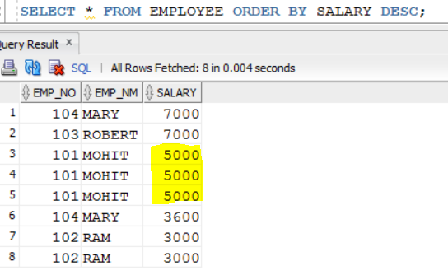

**Query:-**

--1ST WAY

SELECT MIN(salary)FROM(SELECT DISTINCT salary FROM EMPLOYEE ORDER BY salary DESC)WHERE ROWNUM<=2;

--2ND WAY

SELECT MAX(SALARY) FROM EMPLOYEE WHERE SALARY NOT IN (SELECT MAX(SALARY) FROM EMPLOYEE);

--3RD WAY

SELECT MAX(SALARY) FROM EMPLOYEE WHERE SALARY < (SELECT MAX(SALARY) FROM EMPLOYEE);

--4TH WAY

SELECT SALARY FROM

(SELECT A.*, ROWNUM RNUM FROM

(SELECT DISTINCT SALARY FROM EMPLOYEE ORDER BY SALARY DESC)A WHERE ROWNUM<=2

)B WHERE RNUM>=2;

--5TH WAY

SELECT DISTINCT SALARY FROM EMPLOYEE A WHERE (SELECT COUNT(DISTINCT B.SALARY) FROM EMPLOYEE B WHERE A.SALARY<=B.SALARY)=2;

--6TH WAY

SELECT SALARY FROM (SELECT DISTINCT SALARY,DENSE_RANK()OVER (ORDER BY SALARY DESC)RANKING FROM EMPLOYEE)WHERE RANKING=2;

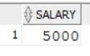

1. **How to find 10th highest salary of employee?**SELECT MIN(SALARY) FROM(SELECT DISTINCT SALARY FROM EMPLOYEE ORDER BY SALARY DESC) WHERE ROWNUM<=10;  
   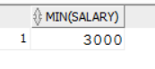

Although we are getting minimum salary of table.

1. **How to find second highest salary in a table based on dept_no?**DROP TABLE "EMPLOYEE";

CREATE TABLE "EMPLOYEE"

( "EMP_NO" NUMBER(*,0),

"EMP_NM" VARCHAR2(20 BYTE),

"SALARY" NUMBER,

"DEPT_NO" NUMBER(*,0)

);

TRUNCATE TABLE EMPLOYEE;

INSERT INTO EMPLOYEE (EMP_NO,EMP_NM,SALARY,DEPT_NO) VALUES (101,'MOHIT',5000,1001);

INSERT INTO EMPLOYEE (EMP_NO,EMP_NM,SALARY,DEPT_NO) VALUES (102,'RAM',3000,1001);

INSERT INTO EMPLOYEE (EMP_NO,EMP_NM,SALARY,DEPT_NO) VALUES (103,'KRISHNA',2000,1001);

INSERT INTO EMPLOYEE (EMP_NO,EMP_NM,SALARY,DEPT_NO) VALUES (104,'JOHN',3000,1002);

INSERT INTO EMPLOYEE (EMP_NO,EMP_NM,SALARY,DEPT_NO) VALUES (105,'MARK',2000,1002);

INSERT INTO EMPLOYEE (EMP_NO,EMP_NM,SALARY,DEPT_NO) VALUES (106,'STEVE',1000,1002);

INSERT INTO EMPLOYEE (EMP_NO,EMP_NM,SALARY,DEPT_NO) VALUES (107,'MARY',4000,1003);

COMMIT;

SELECT * FROM EMPLOYEE ORDER BY DEPT_NO, SALARY DESC;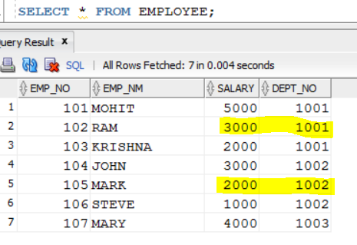

**Query:-**

--1st way

SELECT * FROM(SELECT EMP_NO,EMP_NM,SALARY,DEPT_NO,DENSE_RANK() OVER(PARTITION BY DEPT_NO ORDER BY SALARY DESC) RANKING FROM EMPLOYEE)

WHERE RANKING = 2;  
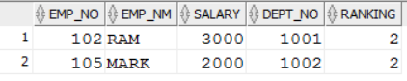

--2nd way

SELECT * FROM(SELECT EMP_NO,EMP_NM,SALARY,DEPT_NO,RANK() OVER(PARTITION BY DEPT_NO ORDER BY SALARY DESC) RANKING FROM EMPLOYEE)

WHERE RANKING = 2;  


--3rd way

SELECT * FROM(SELECT EMP_NO,EMP_NM,SALARY,DEPT_NO,ROW_NUMBER() OVER(PARTITION BY DEPT_NO ORDER BY SALARY DESC) RANKING FROM EMPLOYEE)

WHERE RANKING = 2;  


--4th way

SELECT DEPT_NO,MAX(SALARY)

FROM (SELECT A.DEPT_NO,A.SALARY FROM EMPLOYEE A,(SELECT DEPT_NO,MAX(SALARY) AS SALARY FROM EMPLOYEE GROUP BY DEPT_NO) B

WHERE A.DEPT_NO = B.DEPT_NO

AND A.SALARY<B.SALARY) E

GROUP BY DEPT_NO;

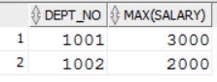

--5th way

SELECT e1.dept_no ,max(e1.salary) FROM employee e1

WHERE salary < (SELECT max(salary) FROM employee e2

WHERE e2.dept_no = e1.dept_no)

GROUP BY e1.dept_no;

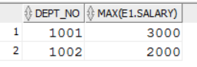

1. **How to find EMPNO which is working on multiple department?**

DROP TABLE "EMPLOYEE";

CREATE TABLE "EMPLOYEE"

( "EMP_NO" NUMBER(*,0),

"EMP_NM" VARCHAR2(20 BYTE),

"SALARY" NUMBER,

"DEPT_NO" NUMBER(*,0)

);

TRUNCATE TABLE EMPLOYEE;

INSERT INTO EMPLOYEE (EMP_NO,EMP_NM,SALARY,DEPT_NO) VALUES (101,'MOHIT',5000,1001);

INSERT INTO EMPLOYEE (EMP_NO,EMP_NM,SALARY,DEPT_NO) VALUES (101,'RAM',3000,1002);

INSERT INTO EMPLOYEE (EMP_NO,EMP_NM,SALARY,DEPT_NO) VALUES (102,'KRISHNA',2000,1002);

INSERT INTO EMPLOYEE (EMP_NO,EMP_NM,SALARY,DEPT_NO) VALUES (103,'JOHN',3000,1002);

INSERT INTO EMPLOYEE (EMP_NO,EMP_NM,SALARY,DEPT_NO) VALUES (104,'MARK',2000,1003);

INSERT INTO EMPLOYEE (EMP_NO,EMP_NM,SALARY,DEPT_NO) VALUES (104,'STEVE',1000,1002);

COMMIT;

SELECT * FROM EMPLOYEE;  
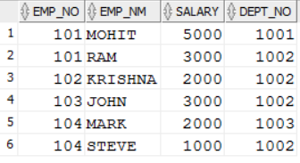

Select * From EMPLOYEE A

Where EXISTS (select 1 FROM EMPLOYEE B WHERE A.EMP_NO=B.EMP_NO

AND A.DEPT_NO <> B.DEPT_NO);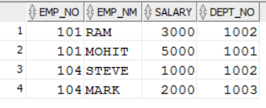

1. **Scenario:- How to convert single row into multiple rows?  
   Source Table:-**

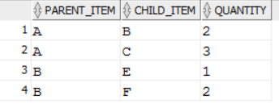

**Target Table:-**

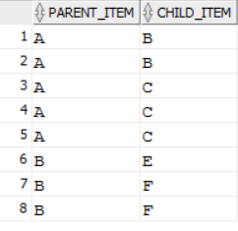

Solution:-

CREATE TABLE TEST (parent_item varchar2(50),child_item varchar2(50),quantity varchar2(50));

INSERT INTO TEST VALUES('A','B',2);

INSERT INTO TEST VALUES('A','C',3);

INSERT INTO TEST VALUES('B','E',1);

INSERT INTO TEST VALUES('B','F',2);

SELECT * FROM TEST;

SELECT DISTINCT PARENT_ITEM, CHILD_ITEM, QUANTITY, LEVEL LEVEL_TAG

FROM TEST CONNECT BY QUANTITY>=LEVEL

ORDER BY 1 ASC;

1. **Scenario:- How to convert single row into multiple rows?  
   Source Table:- A B C D**

**Target Table:-**

**A**

**A B**

**A B C**

**A B C D**Solution:-  
DROP TABLE TEST;

CREATE TABLE TEST(FIRST_NAME VARCHAR2(25),MIDDLE_NAME VARCHAR2(25),LAST_NAME VARCHAR2(25));

INSERT INTO TEST values('A','B','C');

SELECT * FROM TEST;

SELECT FIRST_NAME,NULL,NULL,NULL FROM TEST

UNION

SELECT FIRST_NAME,MIDDLE_NAME,NULL,NULL FROM TEST

UNION

SELECT FIRST_NAME,MIDDLE_NAME,LAST_NAME,NULL FROM TEST ORDER BY 1,2 desc,3 desc;

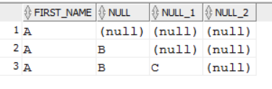

1. **Scenario:- How to convert multiple row into single row?  
   Source Table:-**

**1 Mumbai**

**2 Mumbai**

**3 Mumbai**

**1 Pune**

**2 Pune**

**Target Table:-**

**Mumbai 1 2 3**

**Pune 1 2**

Solution:-

CREATE TABLE TEST(CODE INTEGER,CITY_NAME VARCHAR2(25));

INSERT INTO TEST values(1,'Mumbai');

INSERT INTO TEST values(2,'Mumbai');

INSERT INTO TEST values(3,'Mumbai');

INSERT INTO TEST values(1,'Pune');

INSERT INTO TEST values(2,'Pune');

SELECT * FROM TEST;

SELECT CITY_NAME, LISTAGG(CODE, ' ') WITHIN GROUP (ORDER BY CODE) "names" FROM TEST GROUP BY CITY_NAME;  
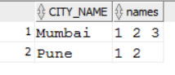

1. **Scenario:- Print previous row data?**

**Input:- Col1 1 2 3 4 5**

**Output:-**

**Col1 Col2**

**1 NULL**

**2 1**

**3 2**

**4 3**

**5 4**

SELECT OFFICE_ID,LAG(OFFICE_ID,1) OVER(ORDER BY OFFICE_ID) FROM PIT_STG.OFFIC;

1. **Scenario:- Sum of previous row data?**

**Input:- 1 2 3 4 5**

**Output:-**

**1 1**

**2 3**

**3 6**

**4 10**

**5 15**

SELECT OFFICE_ID , (select sum(OFFICE_ID) from PIT_STG.OFFICE b where b.OFFICE_ID<=a.OFFICE_ID) as total from PIT_STG.OFFICE a;

1. **Scenario:- Differentiate numbers and alphabets?**

**123ABCD**

**786AB56**

**BAHD786**

1. **How to fetch monthly salary of Employee if annual salary is given?**

SELECT emp_nm,salary/12 AS MONTHLY_salary FROM EMPLOYEE;

1. **What is the Query to fetch first record from Employee table?**

SELECT * FROM EMPLOYEE WHERE ROWNUM =1;

1. **What is the Query to fetch last record from the table?**

SELECT * FROM EMPLOYEE WHERE ROWID= (SELECT MAX(ROWID) FROM EMPLOYEE);

1. **What is Query to display last 5 Records from Employee table?**

SELECT * FROM (SELECT * FROM EMPLOYEE E ORDER BY ROWID DESC) WHERE ROWNUM <=5;

1. **What is Query to display Nth Record from Employee table?**

SELECT * FROM ( SELECT A.*, ROWNUM RNUM FROM ( SELECT * from EMPLOYEE ) A WHERE ROWNUM <= 4 ) WHERE RNUM >= 4;

1. **How to get 3 Highest salaries records from Employee table?**

SELECT DISTINCT salary FROM EMPLOYEE A WHERE 3 >= (SELECT COUNT(DISTINCT salary) FROM EMPLOYEE B WHERE A.salary <= B.salary) ORDER BY A.salary DESC;

1. **How to Display Odd rows in Employee table?**

SELECT * FROM(SELECT ROWNUM AS RNO,E.* FROM EMPLOYEE E) WHERE MOD(RNO,2)=1;

1. **How to Display Even rows in Employee table?**

Select * from(Select rownum as rno,E.* from Employee e) where Mod(rno,2)=0;

1. **How to fetch 3rd highest salary using Rank Function?**

select * from (Select Dense_Rank() over ( order by salary desc) as Rnk,E.* from Employee E) where Rnk=3;

1. **How Can i create table with same structure of Employee table?**

Create table Employee_1 as Select * from Employee where 1=2;

1. **How Can i create table with same structure with data of Employee table?**

Create table Employee1 as select * from Employee;

1. **Display first 50% records from Employee table?**

select rownum, e.* from Employee e where rownum<=(select count(*)/2 from Employee);

1. **Display last 50% records from Employee table?**

Select rownum,E.* from Employee E

minus

Select rownum,E.* from Employee E where rownum<=(Select count(*)/2 from Employee);

1. **How do i fetch only common records between 2 tables.**

Select * from Employee;

Intersect

Select * from Employee1;

1. **Find Query to get information of Employee where Employee is not assigned to the department**

Select * from Employee where Dept_no Not in(Select Department_no from Employee);

1. **How to get distinct records from the table without using distinct keyword.**

select * from Employee a where rowid = (select max(rowid) from Employee b where a.emp_id=b.emp_id);

1. **How to write sql query for the below scenario**

**I/p:ORACLE**

**O/p:**

**O**

**R**

**A**

**C**

**L**

**E**

**i.e, splitting into multiple columns a string using sql.**

Select Substr('ORACLE',Level,1) From Dual Connect By Level<= Length('ORACLE');

1. **How to fetch all the records from Employee who’s joining year is 2017?**

select * from Employee where To_char(Joining_date,’YYYY’)='2017';

1. **What is SQL Query to find maximum salary of each department?**

Select Dept_id,max(salary) from Employee group by Dept_id;

1. **How Do you find all Employees with its managers?(Consider there is manager id also in Employee table)**

Select e.employee_name,m.employee name from Employee e,Employee m where e.Employee_id=m.Manager_id;

1. **How to display following using query?**

**\***

**\*\***

**\*\*\***

**We cannot use dual table to display output given above. To display output use any table. I am using Student table.**

SELECT lpad ('*', ROWNUM,'*') FROM Employee WHERE ROWNUM <4;

1. **How to add the email validation using only one query?**

User needs to use REGEXP_LIKE function for email validation.

SELECT Email FROM Employee where NOT REGEXP_LIKE(Email, '[A-Z0-9._%+-]+@[A-Z0-9.-]+\.[A-Z]{2,4}', 'i');

1. **How to display 1 to 100 Numbers with query?**

Select level from dual connect by level <=100;

1. **How to remove duplicate rows from table?**

First Step: Selecting Duplicate rows from table

Tip: Use concept of max (rowid) of table. Click here to get concept of rowid.

Select emp_id FROM Employee WHERE ROWID =

(Select max (rowid) from Employee b where emp_id=b.emp_id);

Step 2: Delete duplicate rows

Delete FROM Employee WHERE ROWID =

(Select max (rowid) from Employee b where emp_id=b.emp_id);

1. **How to find count of duplicate rows?**

Select emp_id, count (emp_id) from Employee Group by emp_id Having count (emp_id)>1

Order by count (emp_id) desc;

1. **How to find max salary of table?**

DROP TABLE "EMPLOYEE";

CREATE TABLE "EMPLOYEE"

( "EMP_NO" NUMBER(*,0),

"EMP_NM" VARCHAR2(20 BYTE),

"SALARY" NUMBER

);

TRUNCATE TABLE EMPLOYEE;

INSERT INTO EMPLOYEE (EMP_NO,EMP_NM,SALARY) VALUES (101,'MOHIT',5000);

INSERT INTO EMPLOYEE (EMP_NO,EMP_NM,SALARY) VALUES (101,'MOHIT',5000);

INSERT INTO EMPLOYEE (EMP_NO,EMP_NM,SALARY) VALUES (101,'MOHIT',5000);

INSERT INTO EMPLOYEE (EMP_NO,EMP_NM,SALARY) VALUES (102,'RAM',3000);

INSERT INTO EMPLOYEE (EMP_NO,EMP_NM,SALARY) VALUES (102,'RAM',3000);

INSERT INTO EMPLOYEE (EMP_NO,EMP_NM,SALARY) VALUES (103,'ROBERT',7000);

INSERT INTO EMPLOYEE (EMP_NO,EMP_NM,SALARY) VALUES (104,'MARY',3600);

INSERT INTO EMPLOYEE (EMP_NO,EMP_NM,SALARY) VALUES (104,'MARY',7000);

COMMIT;

SELECT * FROM EMPLOYEE;  
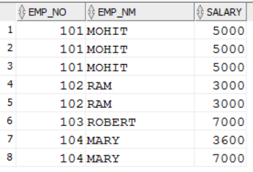

select max(salary) from employee;

7000

1. **How to find max salary of table and print employee details of that salary as well?**

**EMP_NO, EMP_NM, SALARY, MAX_SALARY_OF_TABLE**

**105 Ram 7000 7000**

select * from employee where salary in (select max(salary) from employee);

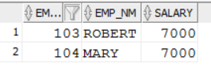  
select * from employee, (select max(salary) AS MAX_SALARY_OF_TABLE from employee) A where salary in (select max(salary) from employee);

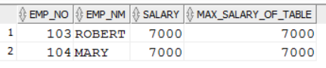

1. **How to find all employee details along with new field of max salary of table?**

**EMP_NO, EMP_NM, SALARY, MAX_SALARY_OF_TABLE**

**101 Ram 3000 7000**

**102 Krishna 2000 7000**select * from employee,(select max(salary) AS MAX_SALARY_OF_TABLE from employee) A;

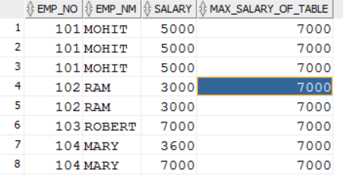

1. **How to find max salary of each department?  
   DEPT_NO, MAX(SALARY)**

**1001 5000**

**1002 8000**DROP TABLE "EMPLOYEE";

CREATE TABLE "EMPLOYEE"

( "EMP_NO" NUMBER(*,0),

"EMP_NM" VARCHAR2(20 BYTE),

"SALARY" NUMBER,

"DEPT_NO" NUMBER(*,0)

);

TRUNCATE TABLE EMPLOYEE;

INSERT INTO EMPLOYEE (EMP_NO,EMP_NM,SALARY,DEPT_NO) VALUES (101,'MOHIT',5000,1001);

INSERT INTO EMPLOYEE (EMP_NO,EMP_NM,SALARY,DEPT_NO) VALUES (102,'RAM',3000,1001);

INSERT INTO EMPLOYEE (EMP_NO,EMP_NM,SALARY,DEPT_NO) VALUES (103,'KRISHNA',2000,1001);

INSERT INTO EMPLOYEE (EMP_NO,EMP_NM,SALARY,DEPT_NO) VALUES (104,'JOHN',3000,1002);

INSERT INTO EMPLOYEE (EMP_NO,EMP_NM,SALARY,DEPT_NO) VALUES (105,'MARK',2000,1002);

INSERT INTO EMPLOYEE (EMP_NO,EMP_NM,SALARY,DEPT_NO) VALUES (106,'STEVE',1000,1002);

INSERT INTO EMPLOYEE (EMP_NO,EMP_NM,SALARY,DEPT_NO) VALUES (107,'MARY',4000,1003);

COMMIT;

SELECT * FROM EMPLOYEE;  
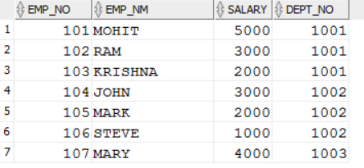

select dept_no, max(salary) from employee group by dept_no;  
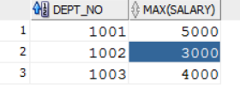

1. **How to find max salary of each department and print employee details of that salary as well?**

**EMP_NO, EMP_NM, SALARY, DEPT_NO, MAX_SALARY_OF_DEPT**

**101 Ram 7000 1111 7000**

**103 Krishna 8000 2222 8000**

select * from (select dept_no,max(salary) AS MAX_SALARY_OF_DEPT from employee group by dept_no) A, employee e where A.dept_no=e.dept_no and a.MAX_SALARY_OF_DEPT=e.salary;

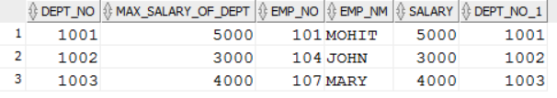

1. **How to find all employee details along with new field of max salary of each department?**

**EMP_NO, EMP_NM, SALARY, DEPT_NO, MAX_SALARY_OF_DEPT**

**101 Ram 3000 1111 7000**

**102 Shyam 4000 1111 7000**

**103 Krishna 2000 2222 8000**

select * from (select dept_no, max(salary) AS MAX_SALARY_OF_DEPT from employee group by dept_no) A, employee e where A.dept_no=e.dept_no;

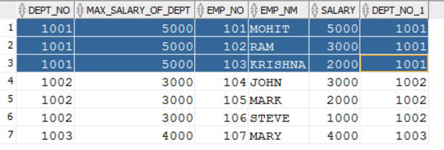

1. **How to get number of employees, max salary and min salary of employee of each department?**

select dept_no,count(*),max(salary),min(salary) from RDO.EMPLOYEE group by dept_no;

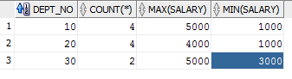

1. **What is avg salary of group 10?**

EMP_ID NAME SALARY DEPT_NO

101 Ram 4000 10

102 Shyam 2000 10

103 Krishna NULL 10

select dept_no,count(*),avg(salary) from rdo.employee group by dept_no;

--3000

select dept_no,count(*),avg(NVL(salary,0)) from rdo.employee group by dept_no;

--2000

1. **If I have 100 rows in A table and 10million rows in B table. How much time it will take to execute query?Also if I have index on table A?**

It depends on database which we are using.

If there are 100 rows in table with index then it won't impact more w.r.t. performance because will prefer to create index if we have millions of records in table.

1. **Find the list of employees who are not managers?**DROP TABLE EMPLOYEE;

CREATE TABLE EMPLOYEE

( EMP_NO NUMBER(20),

EMP_NM VARCHAR2(20 BYTE),

SALARY NUMBER,

DEPT_NO NUMBER(20),

MGR_NO NUMBER(20)

);

TRUNCATE TABLE EMPLOYEE;

INSERT INTO EMPLOYEE VALUES (101,'MOHIT',5000,1001,105);

INSERT INTO EMPLOYEE VALUES (102,'RAM',3000,1001,105);

INSERT INTO EMPLOYEE VALUES (103,'KRISHNA',2000,1001,107);

INSERT INTO EMPLOYEE VALUES (104,'JOHN',3000,1002,107);

INSERT INTO EMPLOYEE VALUES (105,'MARK',2000,1002,107);

INSERT INTO EMPLOYEE VALUES (106,'STEVE',1000,1002,106);

INSERT INTO EMPLOYEE VALUES (107,'MARY',4000,1003,106);

COMMIT;

SELECT * FROM EMPLOYEE ORDER BY DEPT_NO;

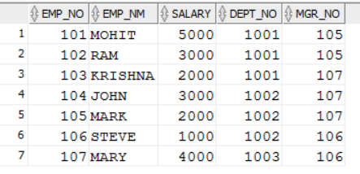

SELECT EMP_NO FROM EMPLOYEE

WHERE EMP_NO NOT IN (SELECT NVL(MGR_NO,0) FROM EMPLOYEE);

--101,102,103,104

SELECT EMP_NO FROM EMPLOYEE A

WHERE EMP_NO NOT IN (SELECT NVL(MGR_NO,0) FROM EMPLOYEE B where A.EMP_NO=B.MGR_NO);

--101,102,103,104

SELECT EMP_NO FROM EMPLOYEE

WHERE EMP_NO NOT IN (SELECT DISTINCT MGR_NO FROM EMPLOYEE WHERE MGR_NO IS NOT NULL);

--101,102,103,104.

1. **Find dept wise MAX salary of employee?**

DROP TABLE EMPLOYEE;

CREATE TABLE EMPLOYEE

( EMP_NO NUMBER(20),

EMP_NM VARCHAR2(20 BYTE),

SALARY NUMBER,

DEPT_NO NUMBER(20),

YEAR TIMESTAMP

);

TRUNCATE TABLE EMPLOYEE;

INSERT INTO EMPLOYEE VALUES (101,'MOHIT',5000,1001,TO_DATE('01-JAN-2018','DD-MON-YYYY'));

INSERT INTO EMPLOYEE VALUES (102,'RAM',3000,1001,TO_DATE('01-JAN-2018','DD-MON-YYYY'));

INSERT INTO EMPLOYEE VALUES (103,'KRISHNA',2000,1001,TO_DATE('01-JAN-2019','DD-MON-YYYY'));

INSERT INTO EMPLOYEE VALUES (104,'JOHN',3000,1002,TO_DATE('01-JAN-2020','DD-MON-YYYY'));

INSERT INTO EMPLOYEE VALUES (105,'MARK',2000,1002,TO_DATE('01-JAN-2020','DD-MON-YYYY'));

INSERT INTO EMPLOYEE VALUES (106,'STEVE',1000,1002,TO_DATE('01-JAN-2018','DD-MON-YYYY'));

INSERT INTO EMPLOYEE VALUES (107,'MARY',4000,1003,TO_DATE('01-JAN-2019','DD-MON-YYYY'));

COMMIT;

SELECT * FROM EMPLOYEE;

SELECT DEPT_NO, MAX(SALARY)

FROM EMPLOYEE GROUP BY DEPT_NO ORDER BY DEPT_NO;

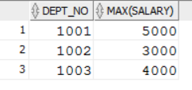

1. **Find dept wise MAX salary of employee in year 2018?**

SELECT DEPT_NO, MAX(SALARY)

FROM EMPLOYEE

where YEAR='01-JAN-2018'

GROUP BY DEPT_NO ORDER BY DEPT_NO;

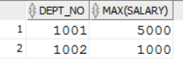

1. **How to find employees whose salary is greater than or equal to the average salary for their departments?**

DROP TABLE EMPLOYEE;

CREATE TABLE EMPLOYEE

( EMP_NO NUMBER(38,0) NOT NULL,

EMP_NAME VARCHAR2(50 CHAR),

SALARY NUMBER(38,0),

DEPT_NM VARCHAR2(50 CHAR),

CONSTRAINT PK_SRC_EMP PRIMARY KEY (EMP_NO)

);

TRUNCATE TABLE EMPLOYEE;

INSERT INTO EMPLOYEE VALUES(101,'JOHN',1000,'HR');

INSERT INTO EMPLOYEE VALUES(102,'SAM',2000,'HR');

INSERT INTO EMPLOYEE VALUES(103,'SHAWN',3000,'HR');

INSERT INTO EMPLOYEE VALUES(104,'STEVE',5000,'FINANCE');

INSERT INTO EMPLOYEE VALUES(105,'MARK',4000,'FINANCE');

INSERT INTO EMPLOYEE VALUES(106,'STUART',3000,'RATINGS');

COMMIT;

SELECT * FROM EMPLOYEE ORDER BY DEPT_NM,SALARY DESC;

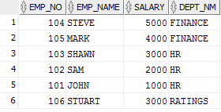

SELECT * FROM EMPLOYEE A,(SELECT DEPT_NM, AVG(SALARY) AS AVG_SAL FROM EMPLOYEE

GROUP BY DEPT_NM

)B

WHERE A.DEPT_NM=B.DEPT_NM AND A.SALARY>=B.AVG_SAL;

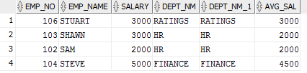

Note:-   
select dept_nm, AVG(SALARY) AS AVG_SAL from employee group by dept_nm;  
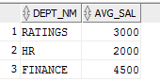

1. **How to find primary key and foreign key of any table?**

SELECT ac.table_name,

column_name,

ac.constraint_name,

DECODE (constraint_type, 'P', 'Primary Key', 'Foreign Key') key_type,

(SELECT ac2.table_name FROM all_constraints ac2 WHERE AC2.CONSTRAINT_NAME = AC.R_CONSTRAINT_NAME) fK_to_table

FROM all_cons_columns acc, all_constraints ac

WHERE acc.constraint_name = ac.constraint_name

AND acc.table_name = ac.table_name

AND CONSTRAINT_TYPE IN ('P', 'R')

AND ac.table_name = 'CONT_COMM'

ORDER BY table_name, constraint_type;

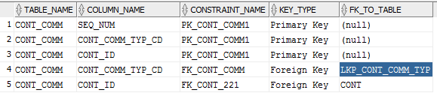

1. **Table A(1,2,3,4,5) and B(1,2,3). How to find records exist in A but not in B and vise-versa?**

create table A(id int);

insert into a values(1);

insert into a values(2);

insert into a values(3);

insert into a values(4);

insert into a values(5);

insert into a values('');

insert into a values('');

commit;

create table B(id int);

insert into B values(1);

insert into B values(2);

insert into B values(3);

insert into B values('');

commit;

select * from A;

select * from B;

select * from a

minus

select * from b;

--4,5

select * from b

minus

select * from a;

--No records

1. **How to find employee details whose start_dtm is max?**

Drop table employee;

create table employee(emp_id int, emp_nm varchar2(50),start_dtm timestamp, end_dtm timestamp);

insert into employee values(2356,'ABC',TO_DATE('01-JAN-2015','DD-MON-YYYY'),TO_DATE('01-DEC-2015','DD-MON-YYYY'));

insert into employee values(2356,'ABC',TO_DATE('01-JAN-2016','DD-MON-YYYY'),TO_DATE('01-DEC-2016','DD-MON-YYYY'));

insert into employee values(2356,'ABC',TO_DATE('01-JAN-2017','DD-MON-YYYY'),TO_DATE('01-DEC-2017','DD-MON-YYYY'));

commit;

select * from employee;

SELECT * FROM employee A

WHERE A.START_DTM = (SELECT MAX(START_DTM) FROM EMPLOYEE B WHERE B.emp_id = A.emp_id AND B.emp_nm = A.emp_nm);

--2356 ABC 01-JAN-2017 12.00.00.000000000 AM 01-DEC-2017 12.00.00.000000000 AM

1. **How to extract those dept numbers which has more than 5 employees in it?**

DROP TABLE EMPLOYEE;

CREATE TABLE EMPLOYEE

( EMP_NO NUMBER(20),

EMP_NM VARCHAR2(20 BYTE),

SALARY NUMBER,

DEPT_NO NUMBER(20)

);

TRUNCATE TABLE EMPLOYEE;

INSERT INTO EMPLOYEE (EMP_NO,EMP_NM,SALARY,DEPT_NO) VALUES (101,'MOHIT',5000,1001);

INSERT INTO EMPLOYEE (EMP_NO,EMP_NM,SALARY,DEPT_NO) VALUES (102,'RAM',3000,1001);

INSERT INTO EMPLOYEE (EMP_NO,EMP_NM,SALARY,DEPT_NO) VALUES (103,'KRISHNA',2000,1001);

INSERT INTO EMPLOYEE (EMP_NO,EMP_NM,SALARY,DEPT_NO) VALUES (103,'KRISHNA',2000,1001);

INSERT INTO EMPLOYEE (EMP_NO,EMP_NM,SALARY,DEPT_NO) VALUES (103,'KRISHNA',2000,1001);

INSERT INTO EMPLOYEE (EMP_NO,EMP_NM,SALARY,DEPT_NO) VALUES (103,'KRISHNA',2000,1001);

INSERT INTO EMPLOYEE (EMP_NO,EMP_NM,SALARY,DEPT_NO) VALUES (104,'JOHN',3000,1002);

INSERT INTO EMPLOYEE (EMP_NO,EMP_NM,SALARY,DEPT_NO) VALUES (105,'MARK',2000,1002);

INSERT INTO EMPLOYEE (EMP_NO,EMP_NM,SALARY,DEPT_NO) VALUES (106,'STEVE',1000,1002);

INSERT INTO EMPLOYEE (EMP_NO,EMP_NM,SALARY,DEPT_NO) VALUES (107,'MARY',4000,1003);

COMMIT;

SELECT * FROM EMPLOYEE;

select dept_no, count(*) from employee group by dept_no

having count(*)>5;

1. **What is the output-select * from bill_itm where NULL=NULL;?**

select * from bill_itm where NULL=NULL;

--No data

Because Oracle cannot NULL with NULL.

select * from dual where NULL=NULL;

--No data

select * from dual where 1=1;

--X

1. **Scenario to find average salary?**

**Suppose we have the EMP table as our source. In the target we want to view those employees whose salary are greater than or equal to the average salary for their departments. Describe your mapping approach?**???

1. **Scenario:- Find top 2 salary of Male and Female from employee table?**

DROP TABLE EMPLOYEE;

CREATE TABLE EMPLOYEE

( EMP_NO NUMBER(*,0),

EMP_NM VARCHAR2(20 BYTE),

GENDER VARCHAR2(20 BYTE),

SALARY NUMBER

);

TRUNCATE TABLE EMPLOYEE;

INSERT INTO EMPLOYEE VALUES (101,'A','M',8000);

INSERT INTO EMPLOYEE VALUES (102,'B','M',1000);

INSERT INTO EMPLOYEE VALUES (103,'C','M',4000);

INSERT INTO EMPLOYEE VALUES (104,'D','M',2000);

INSERT INTO EMPLOYEE VALUES (105,'W','F',1000);

INSERT INTO EMPLOYEE VALUES (106,'X','F',5000);

INSERT INTO EMPLOYEE VALUES (107,'Y','F',3000);

INSERT INTO EMPLOYEE VALUES (108,'Z','F',9000);

COMMIT;

SELECT * FROM EMPLOYEE ORDER BY SALARY DESC;

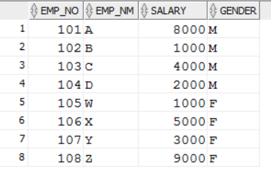

**Logic:-**  
SELECT * FROM

(SELECT EMP_NO,EMP_NM,GENDER,SALARY,

RANK() OVER(PARTITION BY GENDER ORDER BY SALARY DESC) AS MAX_ROWNUM

FROM EMPLOYEE)

WHERE MAX_ROWNUM<=2;

